Name: Yash Daga

Registration Number: 20BCE7323

3)Write a program to check whether given number is prime or not using recursion.

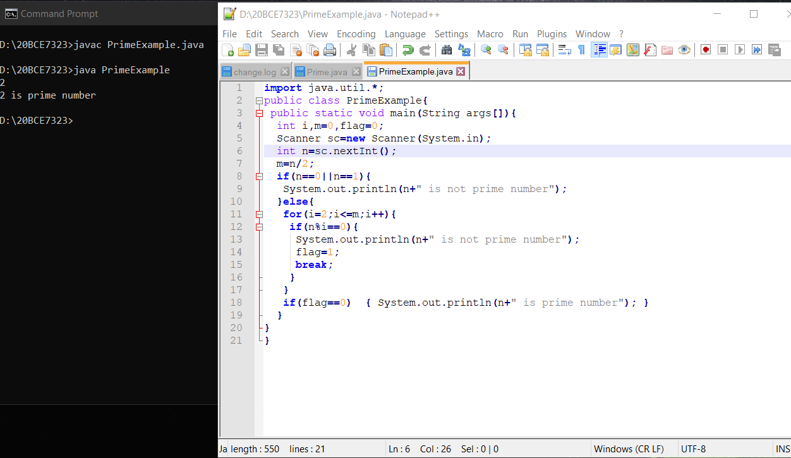

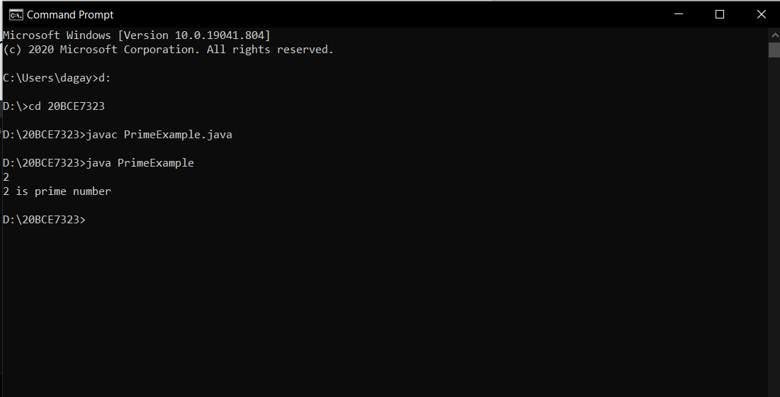

4) Write a program to find reverse of a number 'n" using recursion.

